“CISCO PACKET TRACER”

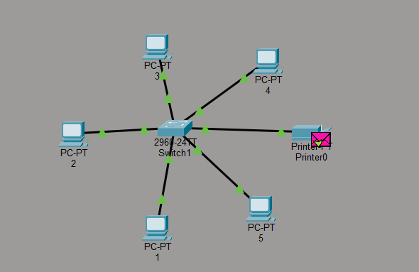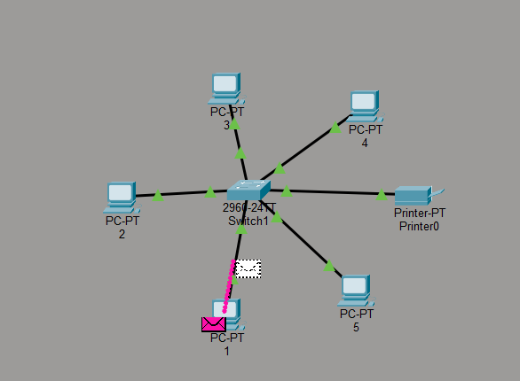

I configured the Printer with the Static IP 192.168.1.10. This establishes it as a Network Printer, allowing all connected PCs (192.168.1.2 - 1.6) to send print packets to it through the switch.
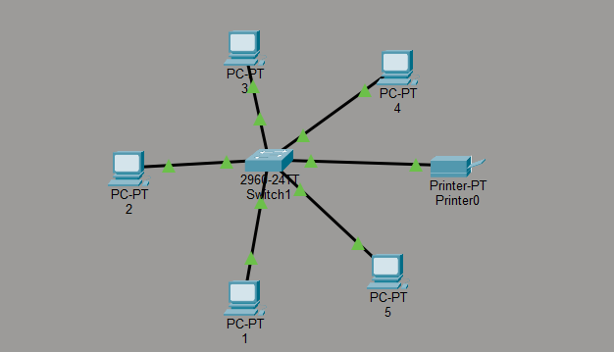
I designed a Star Topology network using a Cisco 2960 Switch as the central device. I placed 5 Generic PCs and 1 Printer in the workspace and connected each end device to the switch's Fast Ethernet ports using Copper Straight-Through cables. This physical arrangement ensures that all data traffic passes through the central switch
I assigned Static IP addresses to all devices to place them on the same local network. I used the Class C private network address 192.168.1.0. Each PC was assigned a unique IP ending in .2 through .6, and the printer was assigned 192.168.1.10. The Subnet Mask for all devices was set to 255.255.255. 0 to define the network portion of the address. 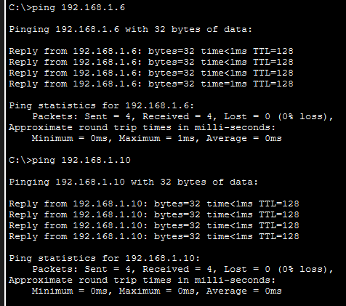
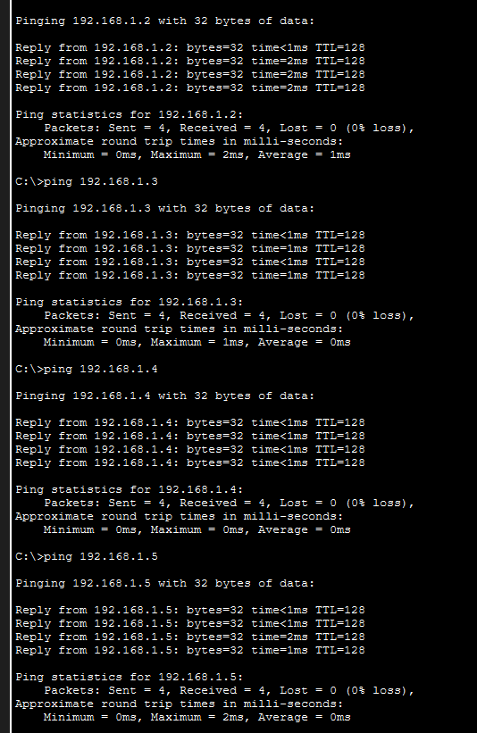
To verify that the network was configured correctly, I performed connectivity tests using the Ping command. I opened the Command Prompt on PC1 and executed ping 192.168.1.6 (to test PC-to-PC connection) and ping 192.168.1.10 (to test PC-to-Printer connection). The tests returned successful replies with 0% packet loss, confirming that the switch is correctly forwarding frames between devices.

